**CIIC has supported 10 startups as part of Global Investor Meet Roadshow**

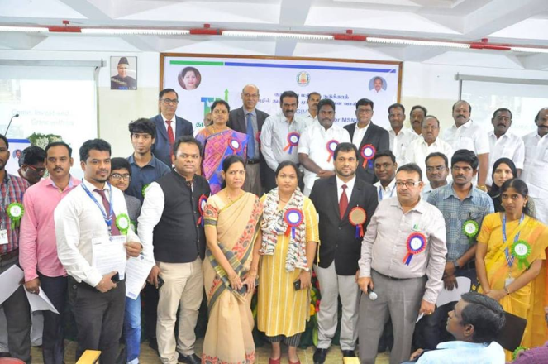

**Venue : B.S. Abdur Rahman University**

**Dept : Crescent Innovation & Incubation Council**

**Date : December 29th,2018**

**Launch of CIIC Incubation Policy and Application for Startups.**

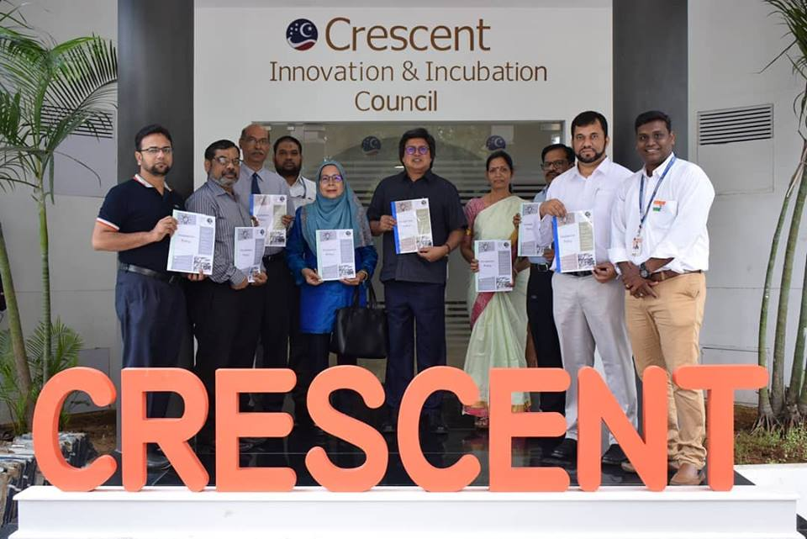

**Our Vice Chancellor Tan Sri Dato Sri Prof.Sahol Hamid Bin Abu Bakar launched the CIIC Incubation Policy and Application for Startups.**

**Venue : B.S. Abdur Rahman University**

**Dept : Crescent Innovation & Incubation Council**

**Date : January 26th,2019**

**Road show on throttling the oil & gas startup Initiative**

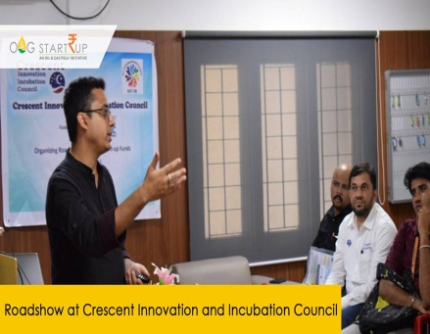

**Venue : B.S. Abdur Rahman University**

**Dept : Crescent Innovation & Incubation Council**

**Date : April 8th,2019**

**Workshop on Digitalizing the Medical world**

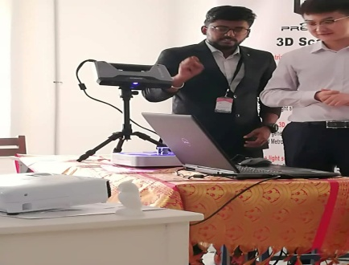

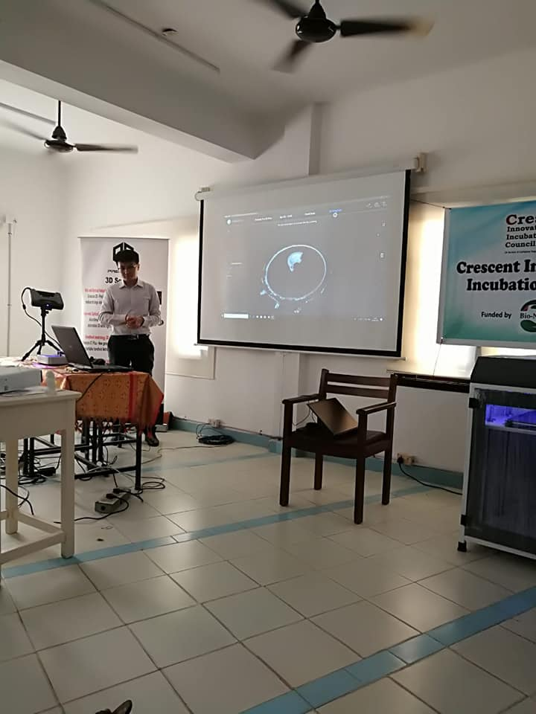

Precise 3D Metrology and Design solutions Pvt .Ltd, Provides comprehensive digital manufacturing solution, which includes 3D scanning ,digital reverse engineering,3D printing and digital inspection for automotive and engineering industries.

**Venue : B.S. Abdur Rahman University**

**Dept : Crescent Innovation & Incubation Council**

**Date : April 24th,2019**

**3D Printing Workshop**

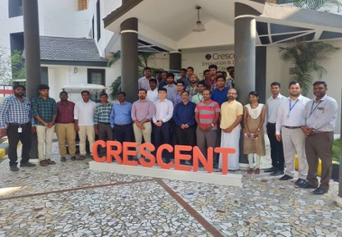

**Venue : B.S. Abdur Rahman University**

**Dept : Crescent Innovation & Incubation Council**

**Date : April 25th,2019**

**Artificial Intelligence Summit**

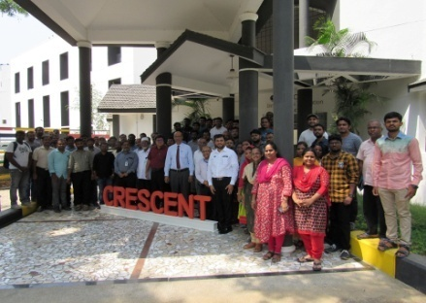

**Venue : B.S. Abdur Rahman University**

**Dept : Crescent Innovation & Incubation Council**

**Date : May 11th,2019**

**City camp on Essentials of Scientific Entrepreneurship**

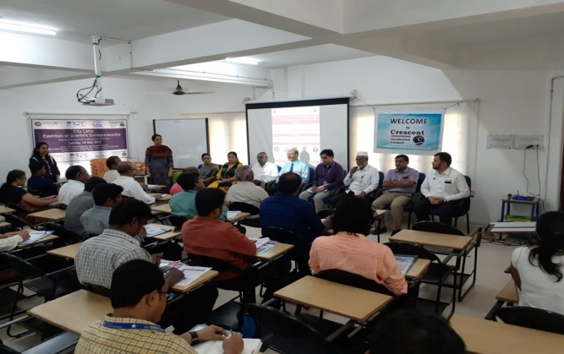 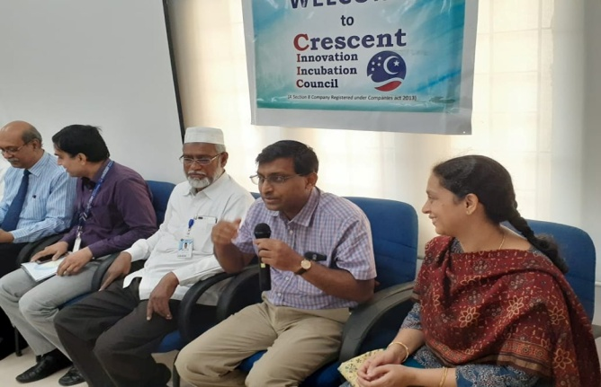

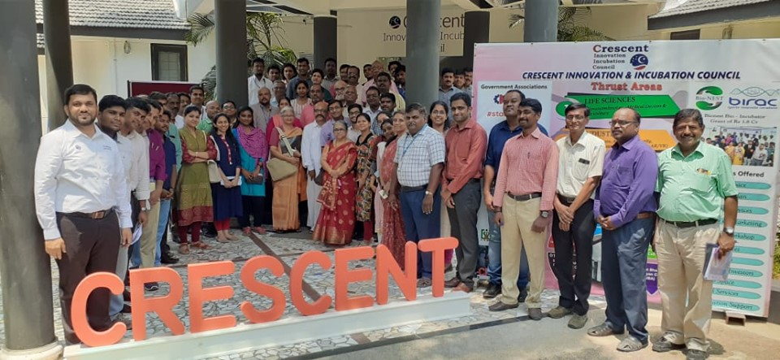

Essentials of Scientific Entrepreneurship, jointly organised by CIIC and Venture Center, Pune. Funded by BIRAC Regional Bio innovation Center. 75+ entrepreneurs, startups across Tamilnadu participated in this program. Thanks to **Dr.Premnath** and Venture Center.

**Venue : B.S. Abdur Rahman University**

**Dept : Crescent Innovation & Incubation Council**

**Date : May 28th,2019**

**C-CAMP**

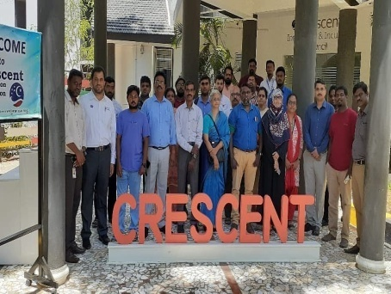

CIIC partnered with CCAMP  to host awareness camp on BIG (Biotech Ignition Grant) scheme of Rs.50 lacs support to startups and faculty  on 12th July Friday at 9.30 am at CIIC Seminar Hall.

**Venue : B.S. Abdur Rahman University**

**Dept : Crescent Innovation & Incubation Council**

**Date : July 12th,2019**

**TIE-Chennai**

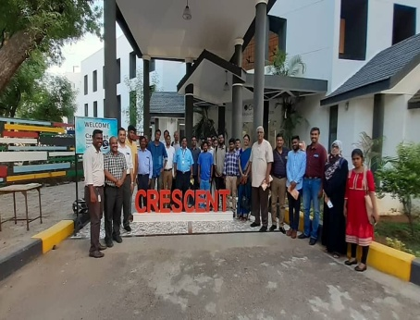

Thanks to TIE Chennai team, CIIC hosted wonderful panel discussion today and many startups were benefited.

**Venue : B.S. Abdur Rahman University**

**Dept : Crescent Innovation & Incubation Council**

**Date : July 12th,2019**

**Herbal Entrepreneurship**

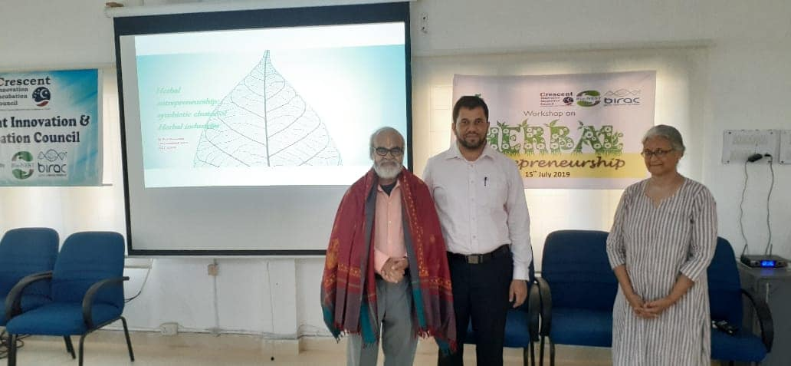 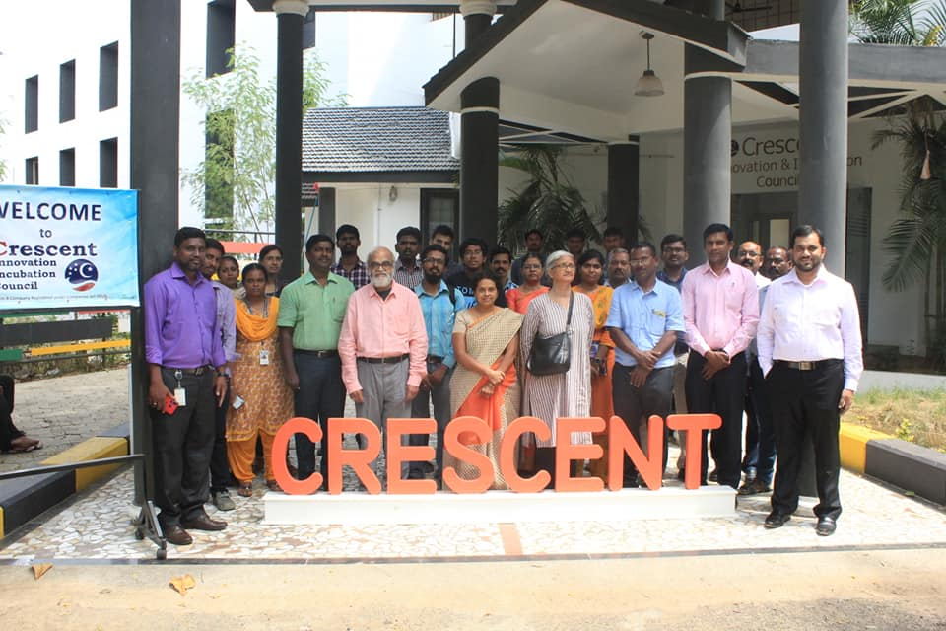

CIIC hosted a "Herbal Entrepreneurship" workshop by Dr.Narasimhan, herbal veteran and founder of Asthagiri Herbal Research Foundation. Many herbal enthusiasts participated and deliberated on the ideas for incubation.

**Venue : B.S. Abdur Rahman University**

**Dept : Crescent Innovation & Incubation Council**

**Date : July 12th,2019**

**Early Stage Finance for Startups** 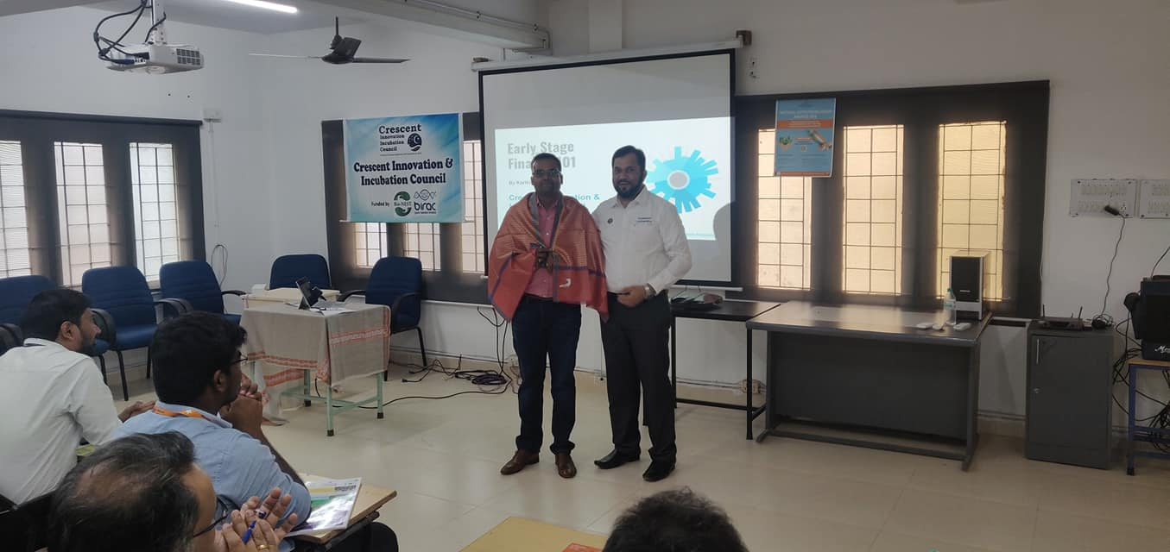 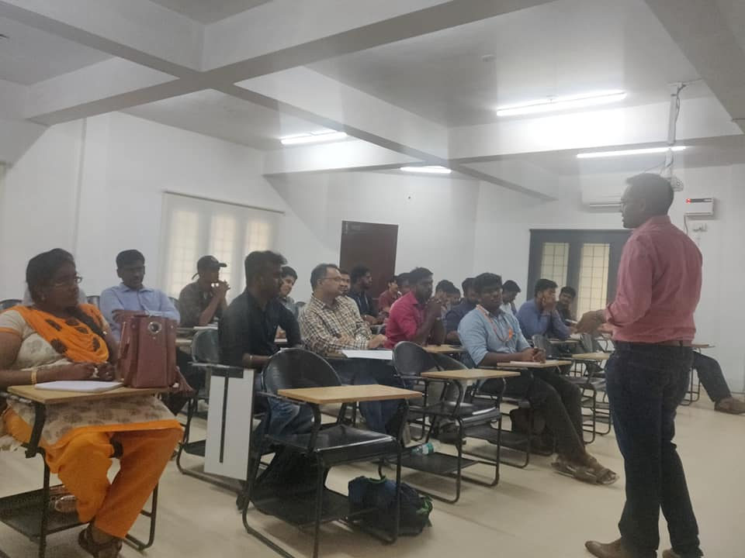

CIIC jointly with Finpreneurs  organised a seminar on the topic "Early Stage Finance for Startups" on today at CIIC Seminar Hall. Mr.Karthikeyan, Founder and Managing Partner of Finpreneurs  has delivered the session and clarified all the queries of startups.

**Venue : B.S. Abdur Rahman University**

**Dept : Crescent Innovation & Incubation Council**

**Date : September 6th,2019**

**IITM Roadshow**

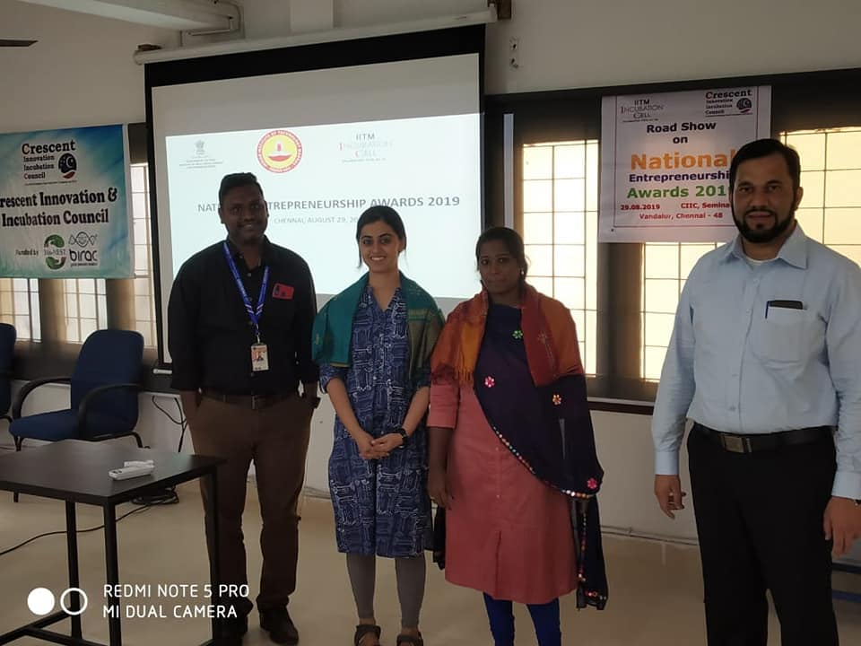

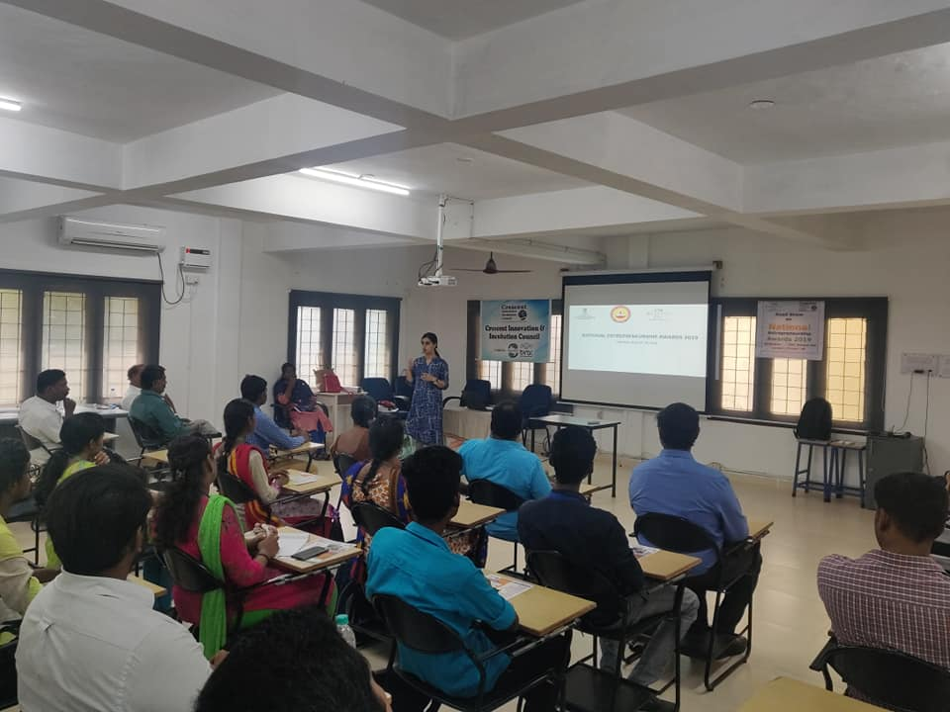

CIIC jointly with IITM Incubation Cell organised roadshow for National Entrepreneurship Awards 2019  at CIIC Seminar Hall. Ms.Kalyani and Ms.Priya from IITM Incubation Cell presented the details about the awards.

**Venue : B.S. Abdur Rahman University**

**Dept : Crescent Innovation & Incubation Council**

**Date : August 29th,2019**

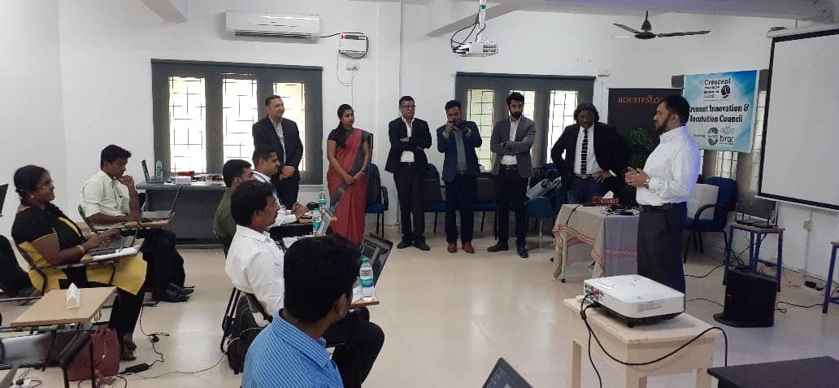

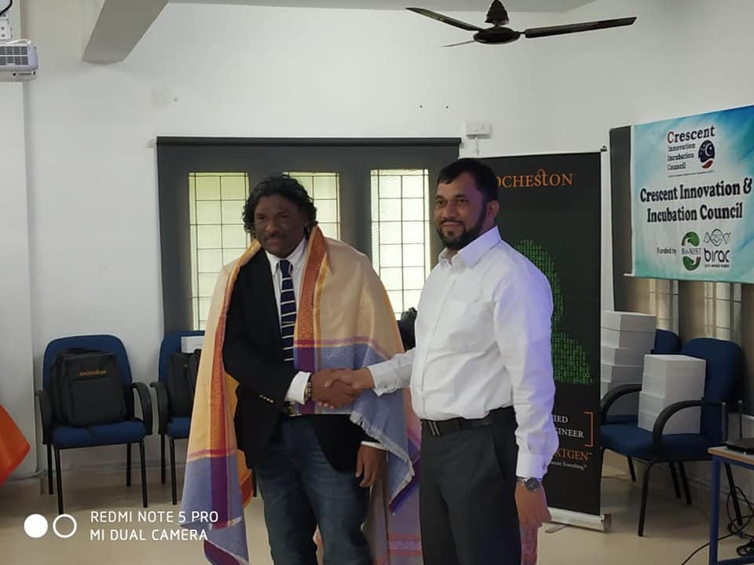

CIIC hosted jointly with Rocheston [https://www.rocheston.com/](https://www.rocheston.com/?fbclid=IwAR1nVfvB6M1rXU4mCEty0rbEwIieuitlhiQ-yj-0YTcMWiH7maBT7VV6h38) 5 day workshop in Cyber security at CIIC. Today the program was inaugurated. The Speaker of the workshop is Mr. Haja, President &CTO, Rocheston ,[https://www.linkedin.com/in/haja](https://l.facebook.com/l.php?u=https%3A%2F%2Fwww.linkedin.com%2Fin%2Fhaja%3Ffbclid%3DIwAR3n0WBmGep0uFO3x2-M4kxPmd4LbSybpxUoeAQpDTjtEsZMROu7GeSY6Vw&h=AT1D_VhtbIzOVWPx6Eg2IejjkFSQf3aPXQRA4dfyyeGbfUoViu6kp1mDK7dH7F_F8TY8Nzxg1YgQuzPP0tkDG1mjEZzU8Q-DYyPJWJ4z1dRdjfdKmtcPIRofAii7Vi7u51ue1O5bNpQL2k2qx16A-67X3x4kx8JWgxaAYQeaWqyZE_mMnsDY1s7Oy0JqpbdH-cQzdLc38yX6WRCp9eUWriWb1rMh1m9WZBwFvqsqtkaJKt_fehzHlETom2tzZa4gx3HvmgZA5U4tr2iwh4X1QZlgq5pYIK41HPfMKozv4uSMmYXZi_5JbJ86El8ntZOBNIhY0OP0gdvTQRDPC2GyNbIM3S8_g6bXEDDHicCc7lwq0sZ2H0XNvnMx0MThsgFA04GPNfdm6ORnnwaD-QrgqE_qA2X2kl-UCyDCtQCWauZefARlkRHMpzBB2pEJkZP6fTeeNe1voKbuWHG2FMa9mTyywXHhvUdc1oty7doIE1R6XV1fgWVO-v0pvY8M0C4RYC57tqKJQQxljo0asI2poL2UL9N8klxGZ6VxsrCF8EDoKqzhXUdfOse5GC5hoUItuRs). At the end of the program the participants will become certified as RCCE (Rocheston Certified Cyber Security Engineer). RCCE is approved by ANSI (American National Standards Institute).

**Venue : B.S. Abdur Rahman University**

**Dept : Crescent Innovation & Incubation Council**

**Date : August 21th,2019**

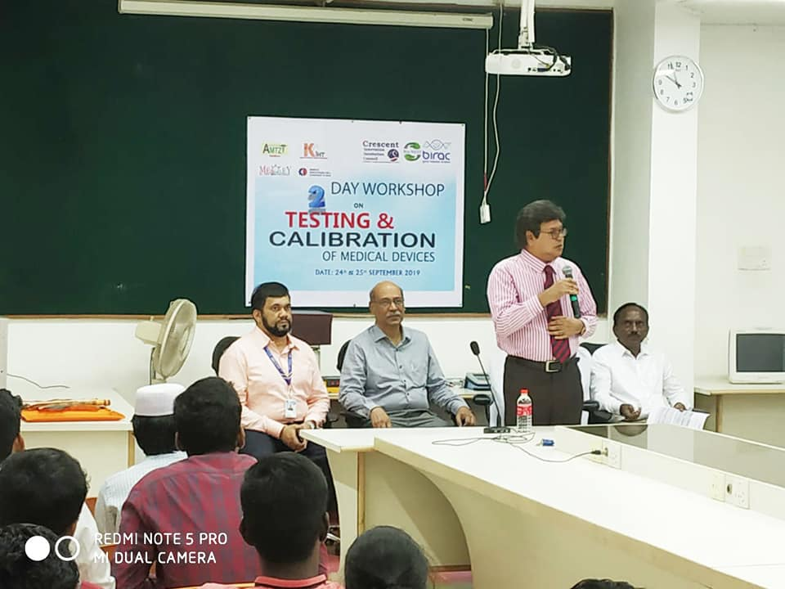

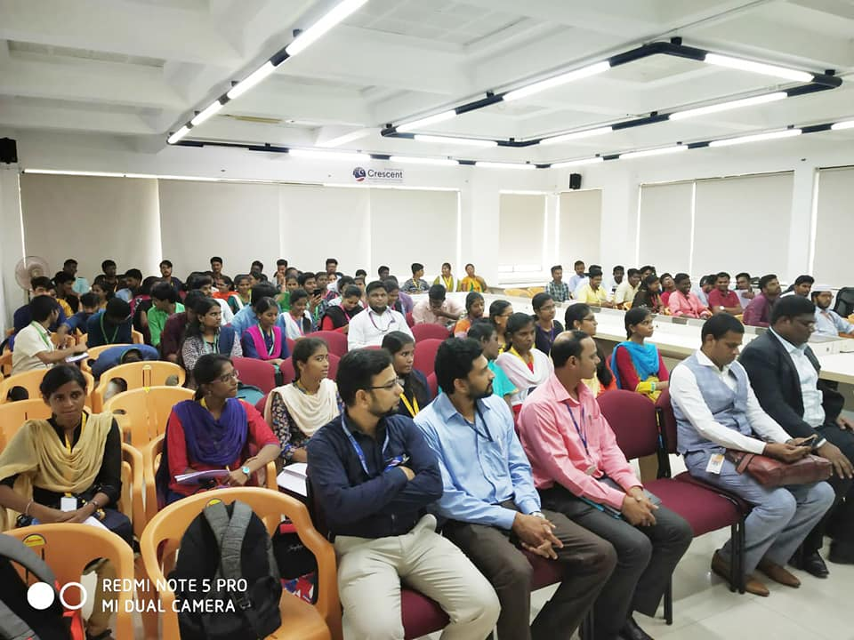

CIIC in association with Andhra Med Tech Zone (AMTZ) [https://amtz.in/](https://l.facebook.com/l.php?u=https%3A%2F%2Famtz.in%2F%3Ffbclid%3DIwAR1P8KXX9TyTbB9oBCZ0stSX0bZIZ5OVlGN0-cC62gODJ7y1goV3jpUENF4&h=AT2SU1ZS21g_zORlI2NyH89935kMCQXpIQAN2Ra8QVCR9fYE794PIXP9W1w5hDDXjL5jMH7B1Nq75ktkZZkHVLyMwsK8D9e_rBHto_Oj4sgBtPGMxSa1GcRp5sL52QOqRfNJn647DJng2l0NpQwePzf87ygmFr5QuEGpgEgZFAlautpL8FFhghfIzaoz1dJINqb1qwuF2qM5rp8MrH694jCjrCZvDpm2XyFn5NIc-CJbvUC26L5QindRYJm0Enms5zDzaUKl_Svj_i46OfSUc-X4MBQiAQFY7z5YRGy4fF3dqy4Swu__wLG23CRrHApHZcbRYmsVVUnPWQs0Qnrw20DMErggH4iW8z9euq3f77EaYQVaQSIkYWHJrJ347dKaI6kxMr_cbNI_Zh7Hx_aw9uaGy7lB5qk4b_2m9EtscpArB6S5LA8w8LmWg0GppAC74q9-QGWLli0_dTYzuQoofbtoGON1sF9tyBTS8qJ7O87ySZc_2TPn8wFMY65qnyYdkhbE3j9BFrxaPK7SuNalBPufAPM5-K73c4Rt0ZkjekDO5a7CI7B_t-r0j-zb) Medivalley [http://medivalley-aic.in/about-amtz/](https://l.facebook.com/l.php?u=http%3A%2F%2Fmedivalley-aic.in%2Fabout-amtz%2F%3Ffbclid%3DIwAR0SF1mxYiNVfUqAa7Erq1UM4azqBEe8MzcHEVYVcf9LL5VI6xbaOT5PHlQ&h=AT0D-n9gRi3J0o9xoVWz3S1xRW0DMv4OaT6q1UYeei318CdDw9MKCGlk6gieHxnArarFDuHDz5yNU5Nzog-y65SZ7h6nfxH9ijokk2tzqK8ZmJysCbBdnWt29QTrTnDjaHDvlFjgbovr_iAIM03XxNtQv3Xr1acB29rS_8Snq8vpvA_Utg-V8jrbkJkAsdw6YZXgTy6a_oVrEtO9tFijiZzjINjo-dyr9BNfS1fInBmG4eK3q31kgulH_oEVn6sN6-6LqC5SGFmMCW379Ejzu45VQtJkvcoY0lOs-RH749OTQEnGcpVnhFmDaYhlkXGxRPJa5b2y2gKaSQ15o5giSnJbRe-rt55PQgcL42DwJzFCuvoeSKQt4Vj2k549OlifidEXb14f0VXDBVmbYg02XjOc-hPOn9WtUTgumIlDM9u7XnhSIeQQ_Ls8TXiuAHh0fz3gVCwFVEGtCDnlUdR0ywb3334I9GvhvFdkq-hifGjdYPf2R1w0eYnQ3y7cq4mTI5Sp-zkjn_ehpeRayX2cEKknmd5t80RhrpGDiKUqxawEBt7f01PjNR5pdWTn) organised 2 day workshop on "Testing & Calibration of Medical Devices" on **24th & 25th Sep 2019.** Our Vice Chancellor inaugurated the workshop and our Registrar did the welcome address. The keynote address was given by Dr.Murugesan, Dean Research, Chettinad Research Academy, Chettinad Hospitals. Mr Dinesh and Mr.Hari from AMTZ conducted the workshop very lively. The program got a overwhelming response of 105 participants across the state of Tamilnadu. Due to the more demand, we will be doing this program in the month of Nov'19 again.